**Read Data from CSV Files to Pandas Dataframes**

To read CSV data into a Pandas DataFrame, we use the pd.read_csv()

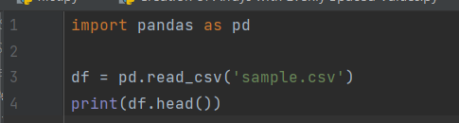

**Output:**

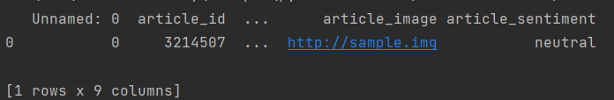

**Filter Data in Pandas Dataframe using query**

The query method is used to filter the DataFrame based on the conditions provided within the string. The resulting DataFrame (filtered_df) will contain only the rows where 'Age' is greater than 25 and 'Salary' is greater than 50000.

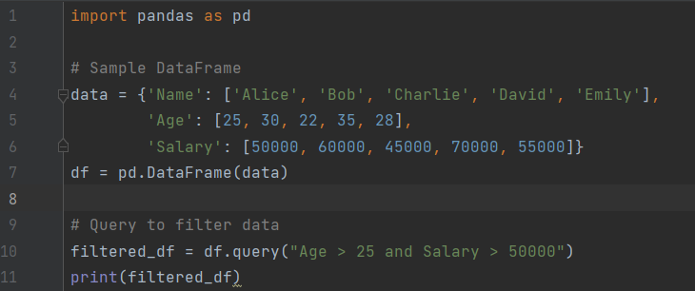

**Output:**

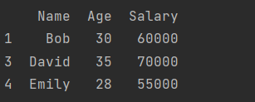

**Get Count by Status using Pandas Dataframe APIs**

To get the count by a specific column, such as ‘Status’ in a Pandas DataFrame, you can use the value_counts() method.

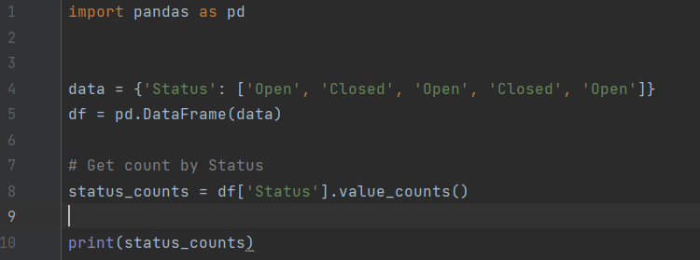

**Output:**

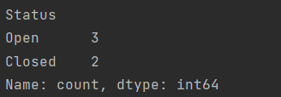

**Get count by Month and Status using Pandas Dataframe APIs**

To get the count by both Month and Status in a Pandas DataFrame, you can use the groupby method to group the data by both columns and then use the size method to get the counts. In this example, the DataFrame is first grouped by the 'Month' and 'Status' columns, and then the size() method is used to get the counts for each group. The result is a DataFrame with counts for each combination of Month and Status.

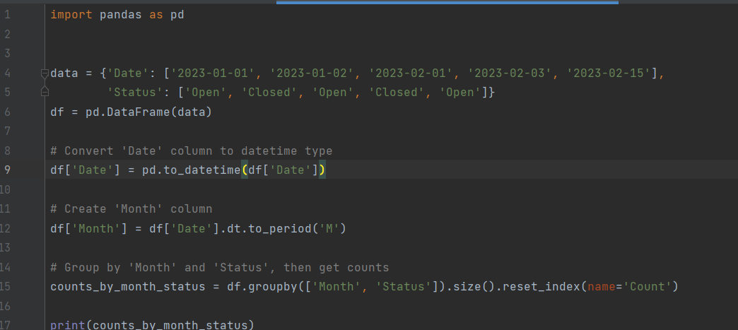

**Output:**

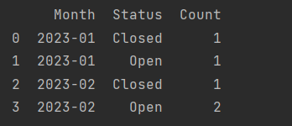

**Create Dataframes using dynamic column list on CSV Data**

To create a DataFrame using a dynamic column list on CSV data in Pandas, you can read the CSV file first and then select the desired columns.

Here we are fetching article_id and article_link columns.

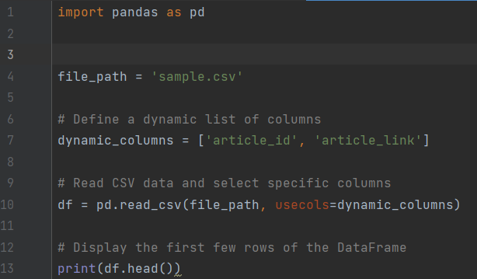

**Output:**

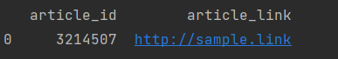

**Performing Inner Join between Pandas Dataframes**

Performing an inner join between Pandas DataFrames can be done using the merge function.

Here we joined using ID.

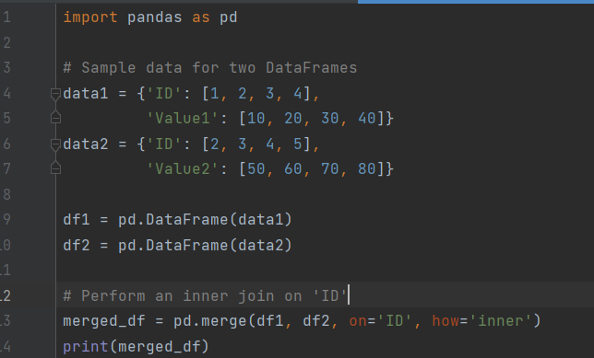

**Output:**

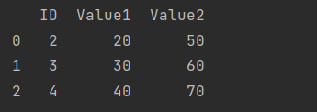

**Perform Aggregations on Join results**

After performing a join between two Pandas DataFrames, you can perform aggregations on the joined results using the groupby function along with aggregation functions.

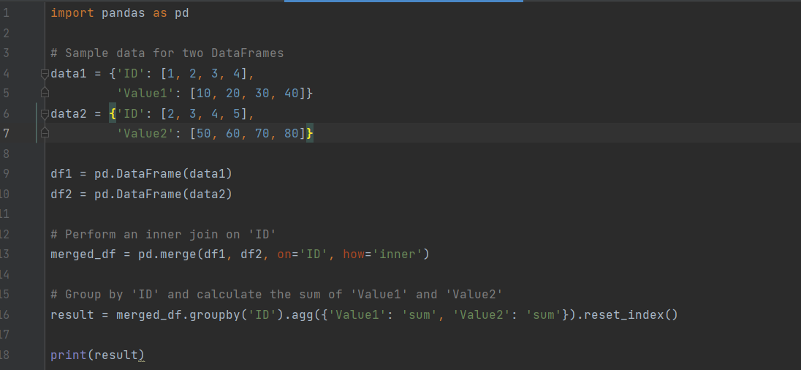

**Output:**

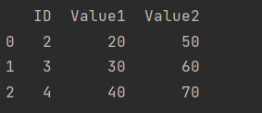

**Sort Data in Pandas Dataframes**

To sort data in a Pandas DataFrame, you can use the sort_values method. Here we sorted by ‘Age’.

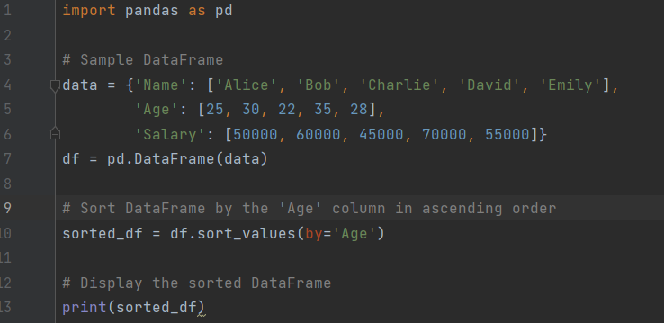

**Output:**

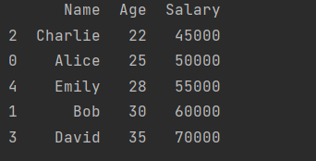

**Writing Pandas Dataframes to Files**

We use ‘to_csv’ function to write the dataframes to csv file. Here we created a csv file written some data to it.

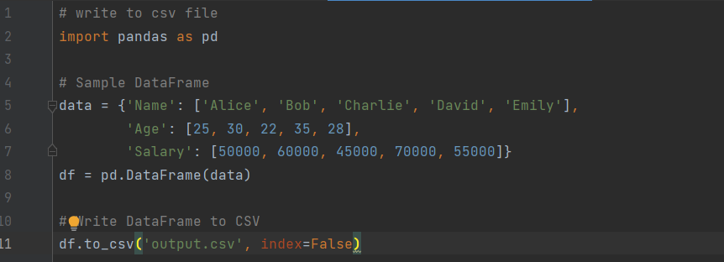

**Output:**

**Output.csv file**

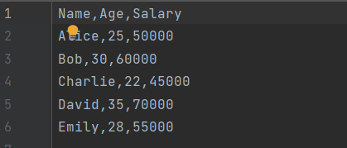

**Write Pandas Dataframes to JSON Files**

We use ‘to_json’ function to write the dataframes to json file. Here we created a json file written some data to it.

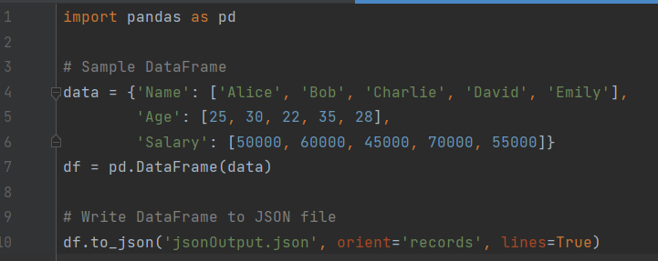

**Output:**

**jsonOutput.json file**

